Day 5 - 30th May 2025

Your Doc name: Linux

Id: hkumarzh (109940031)

Name: Hemant Kumar

Task 1 to 5

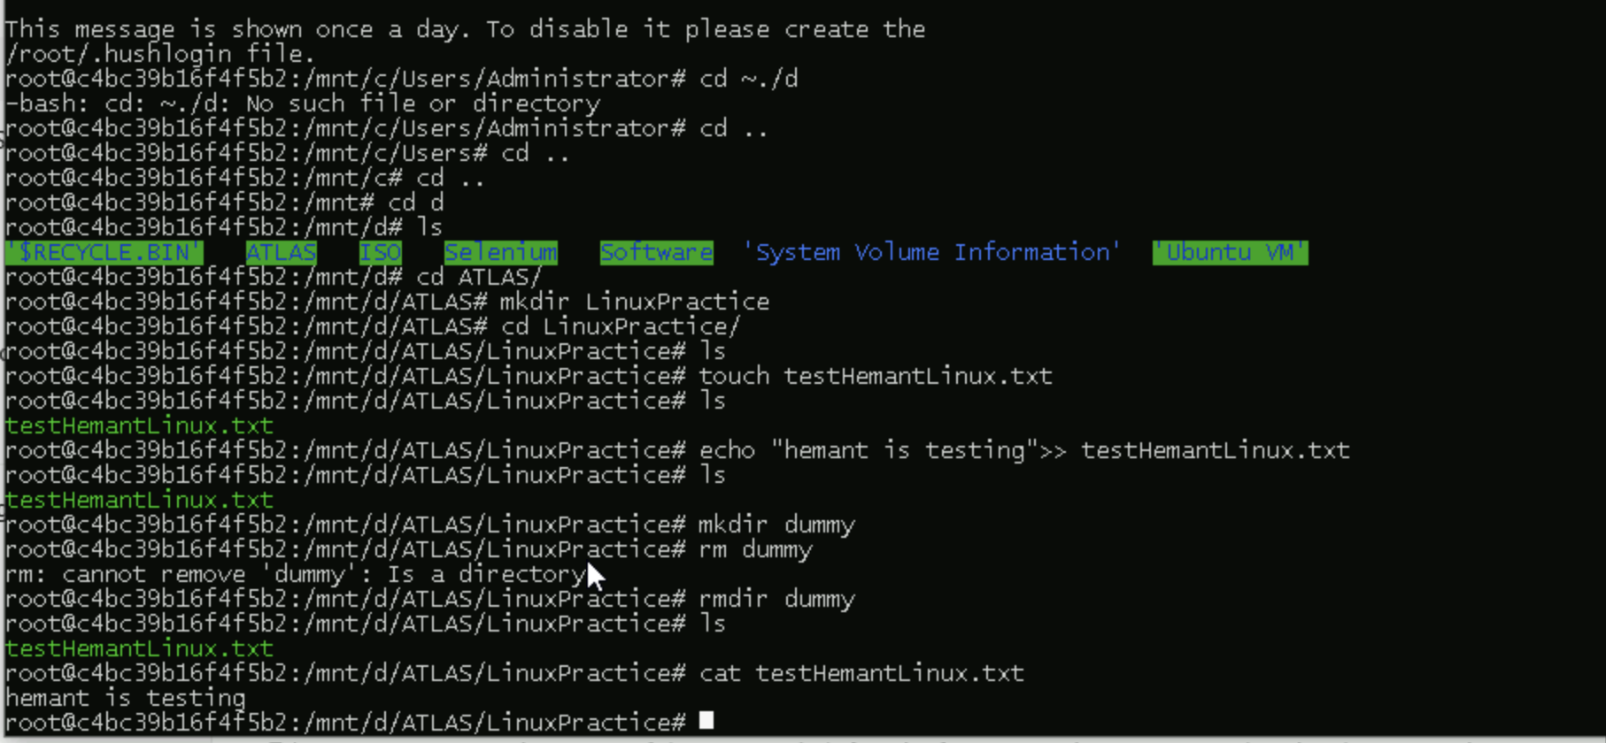

Task 6 -9

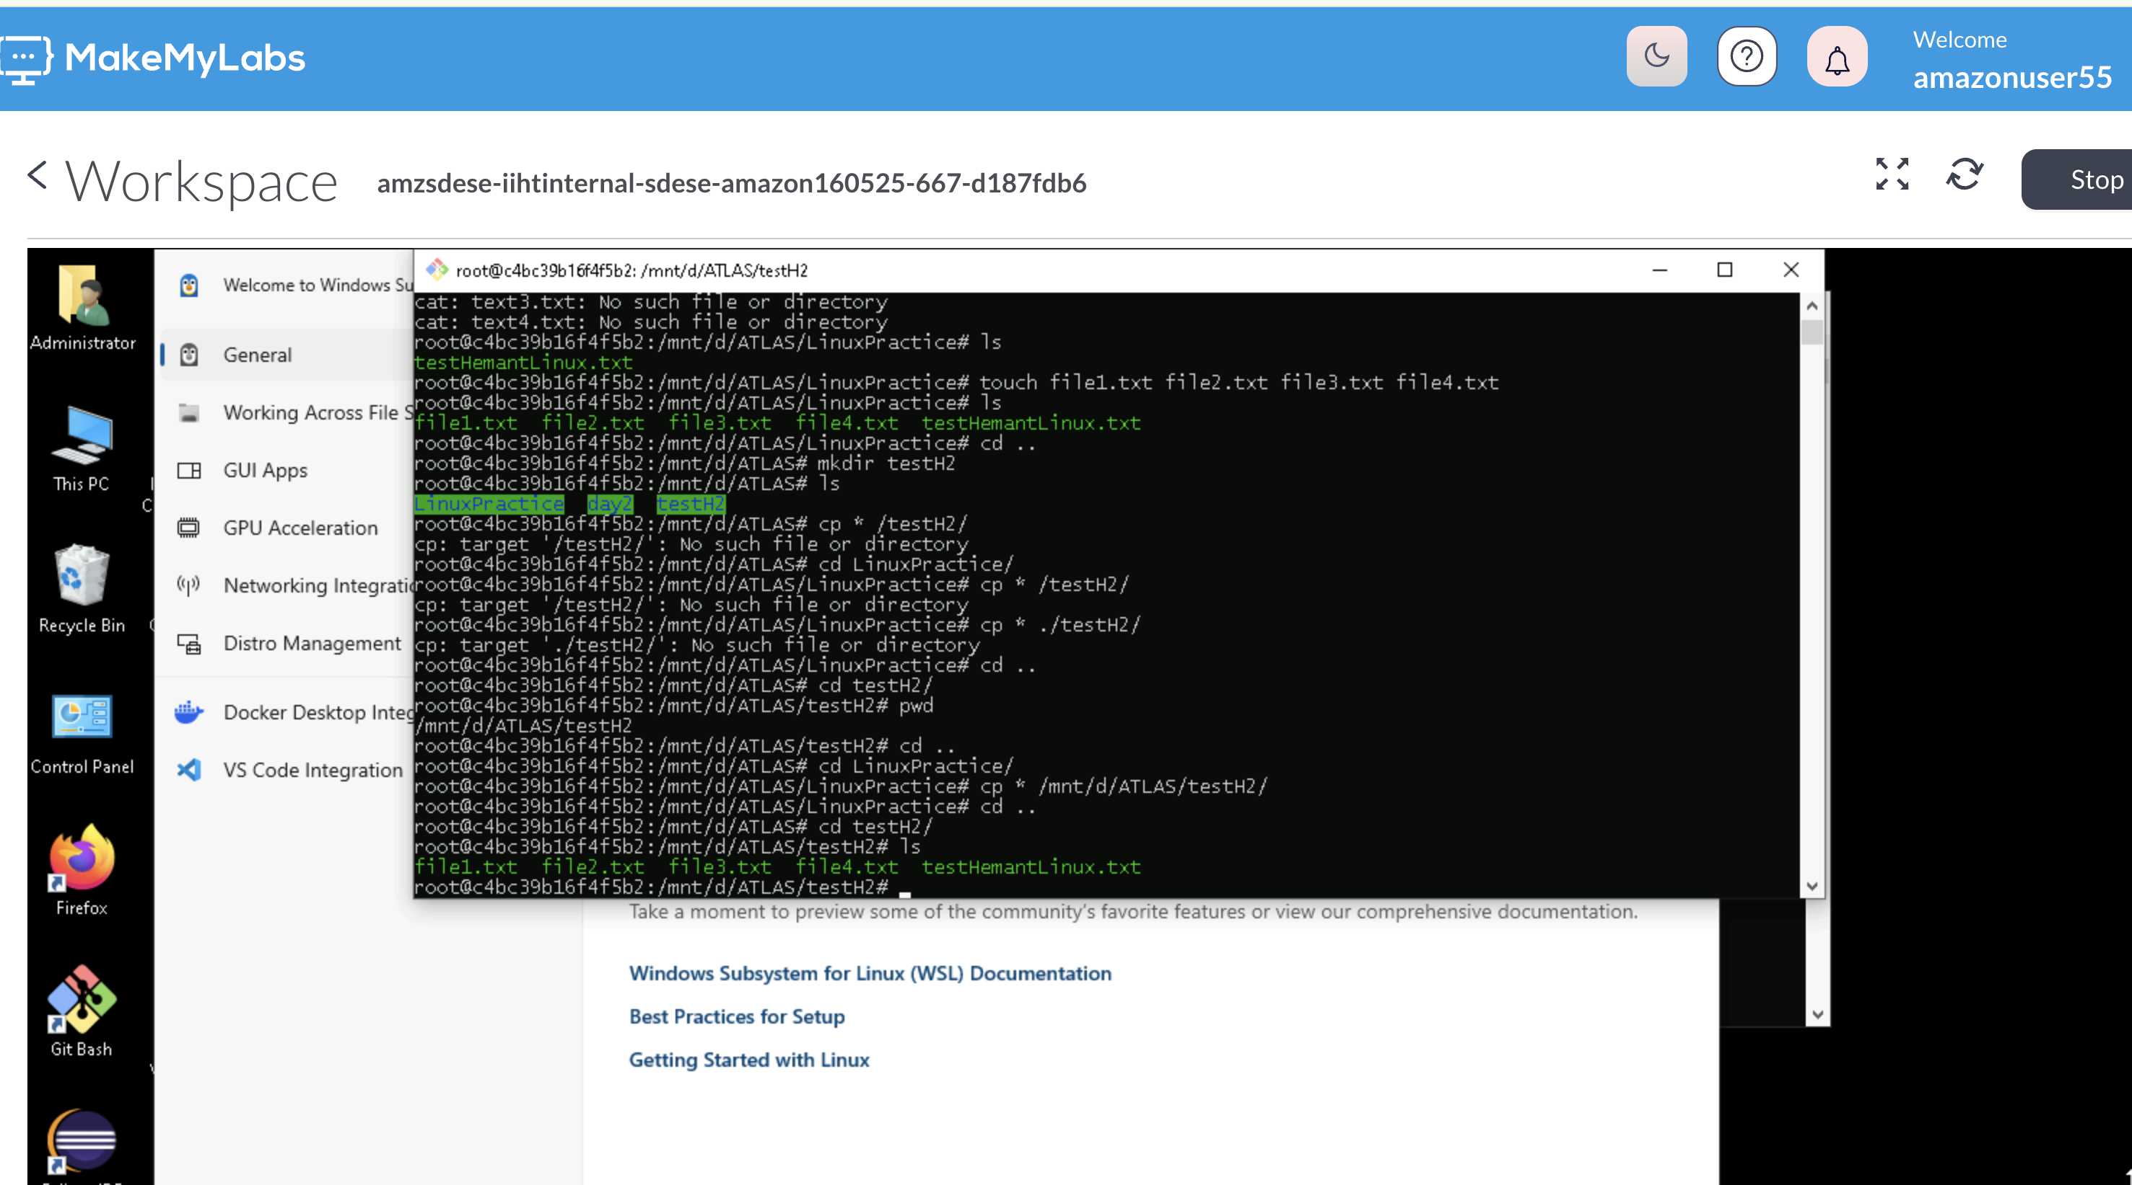

Task 10 – Screenshot of rm vs rmdir

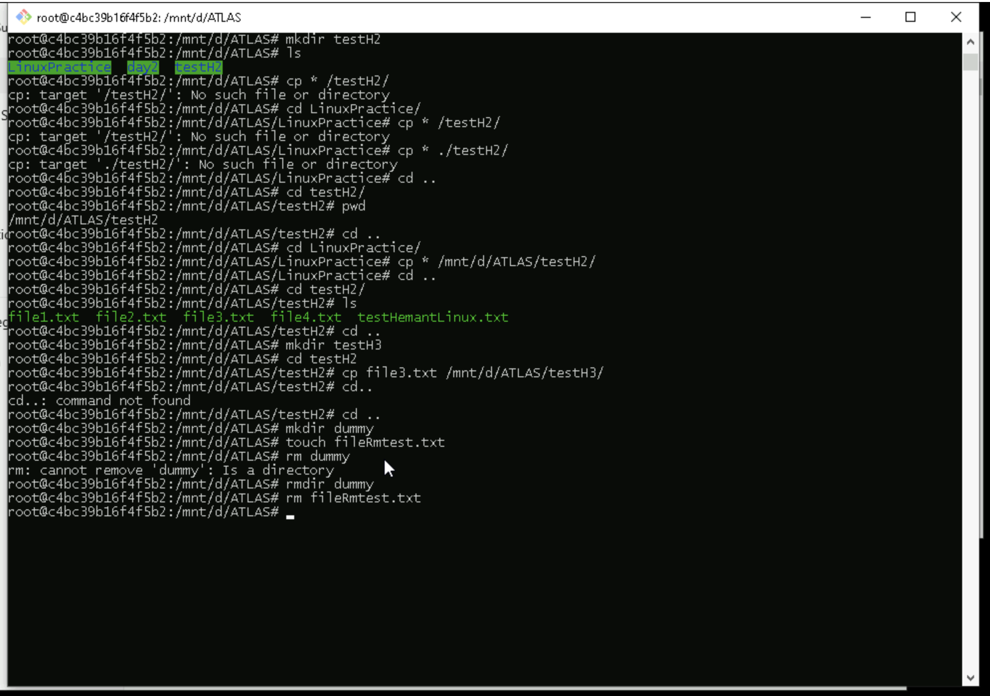

Task 11 – 15

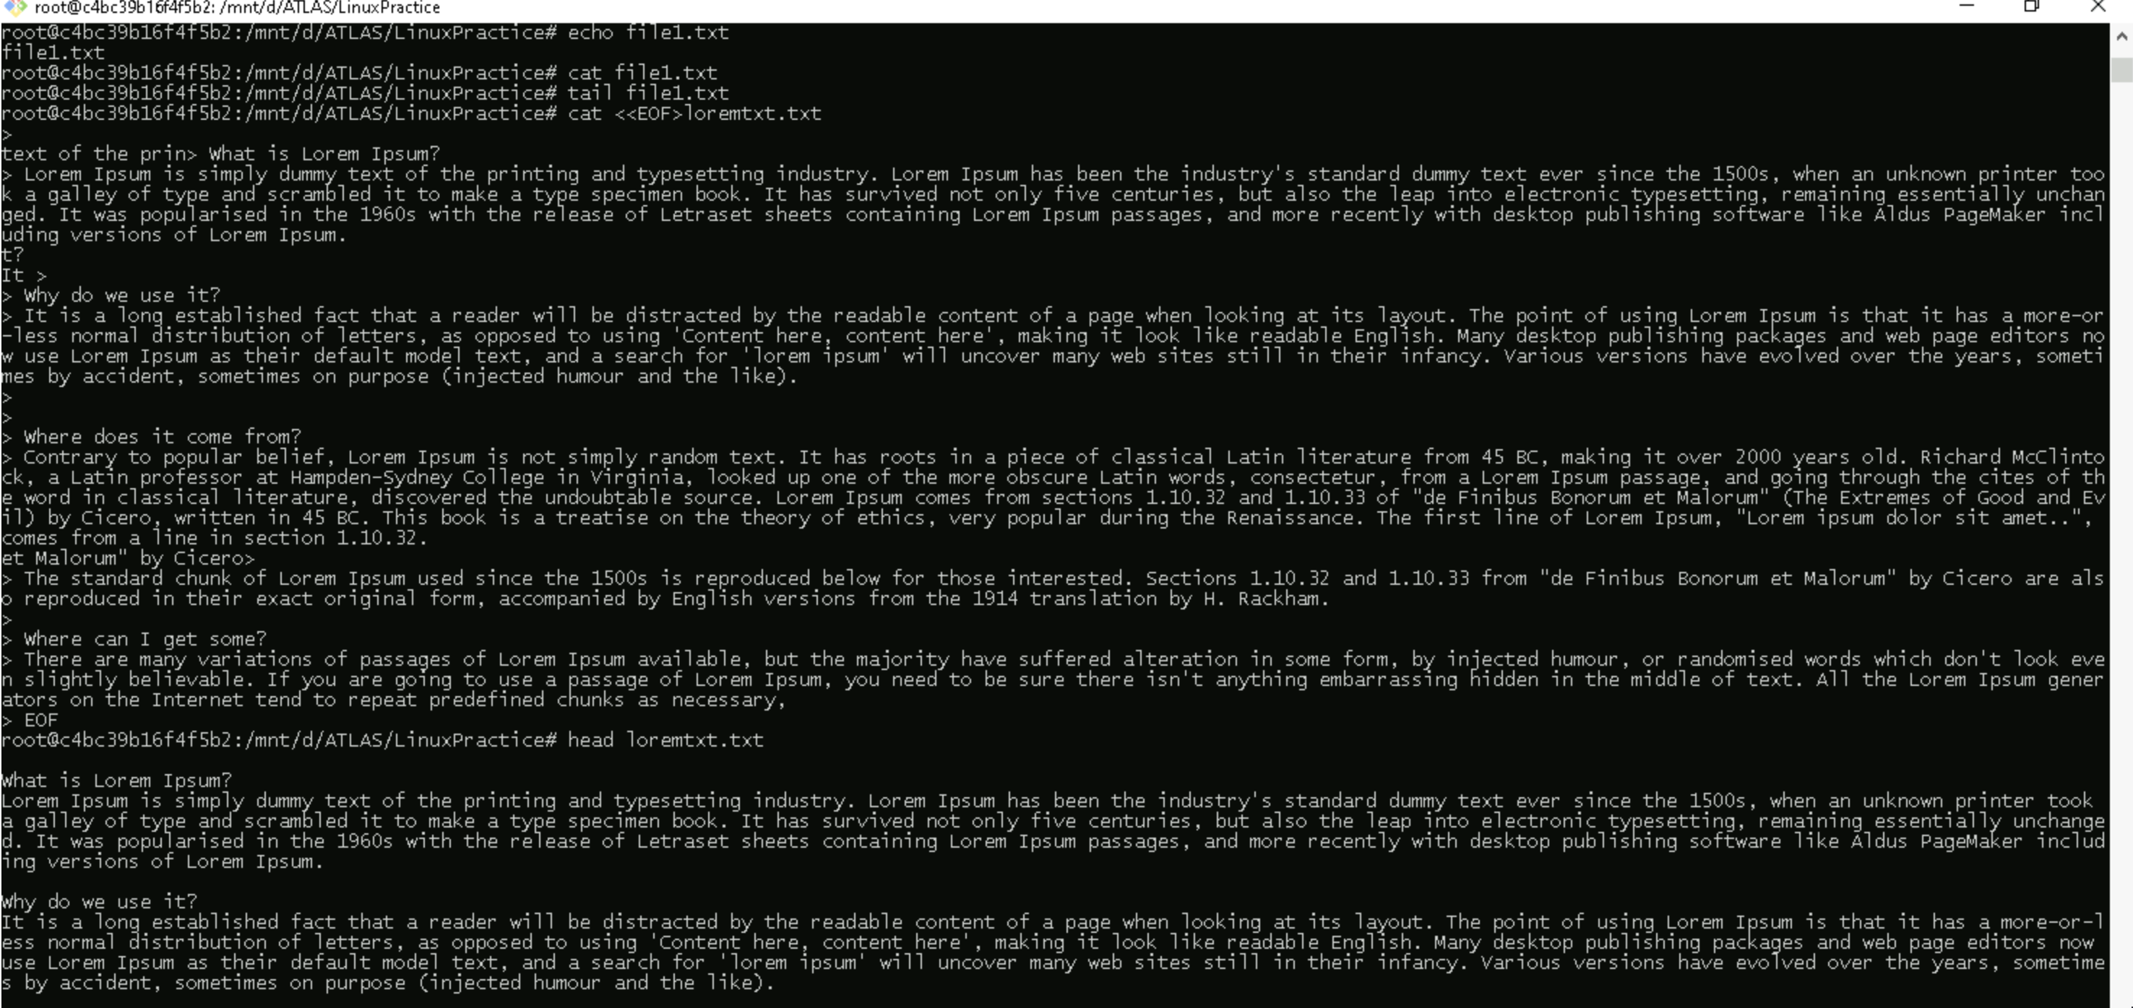

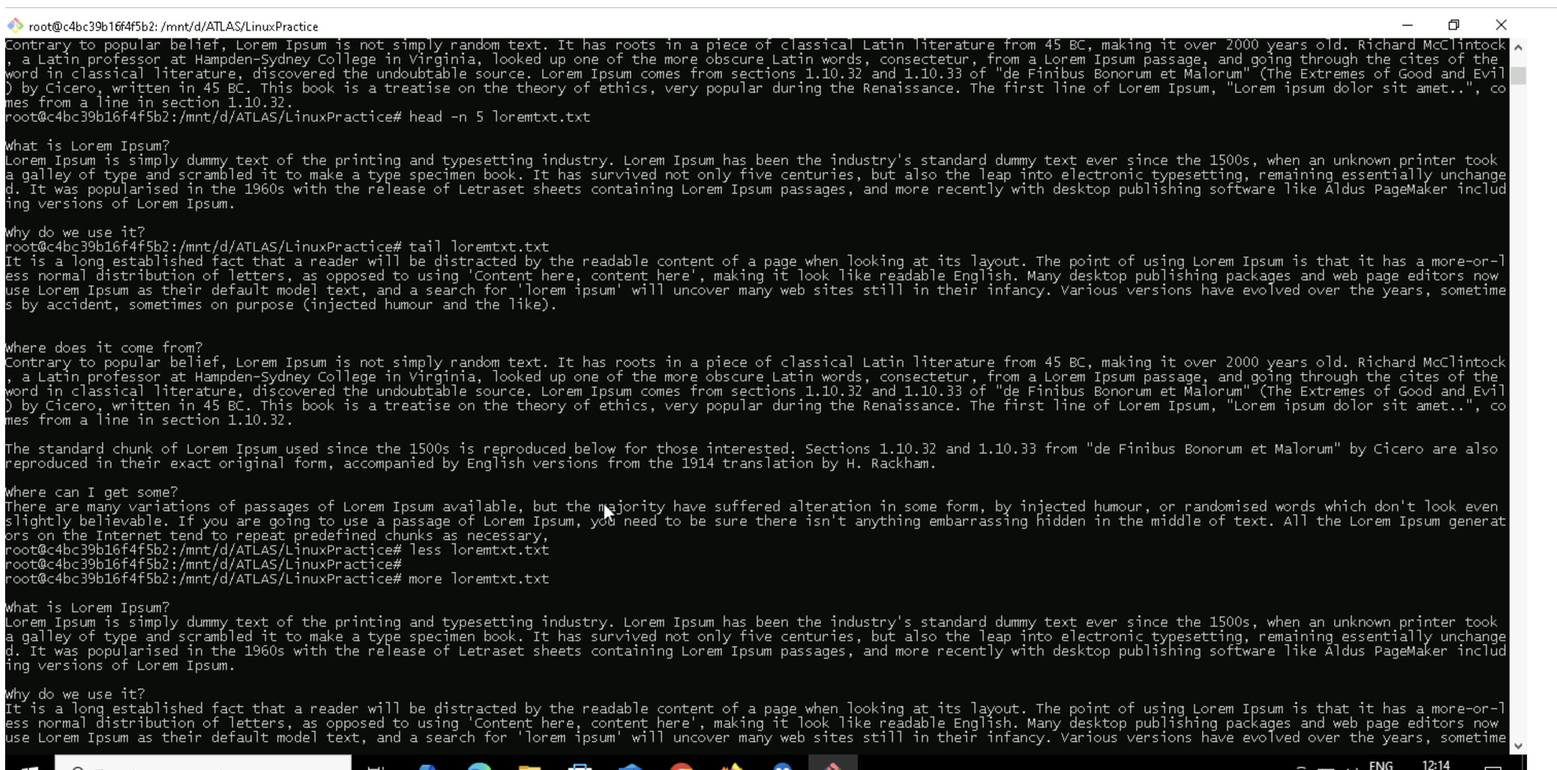

Task 16 echo with -e

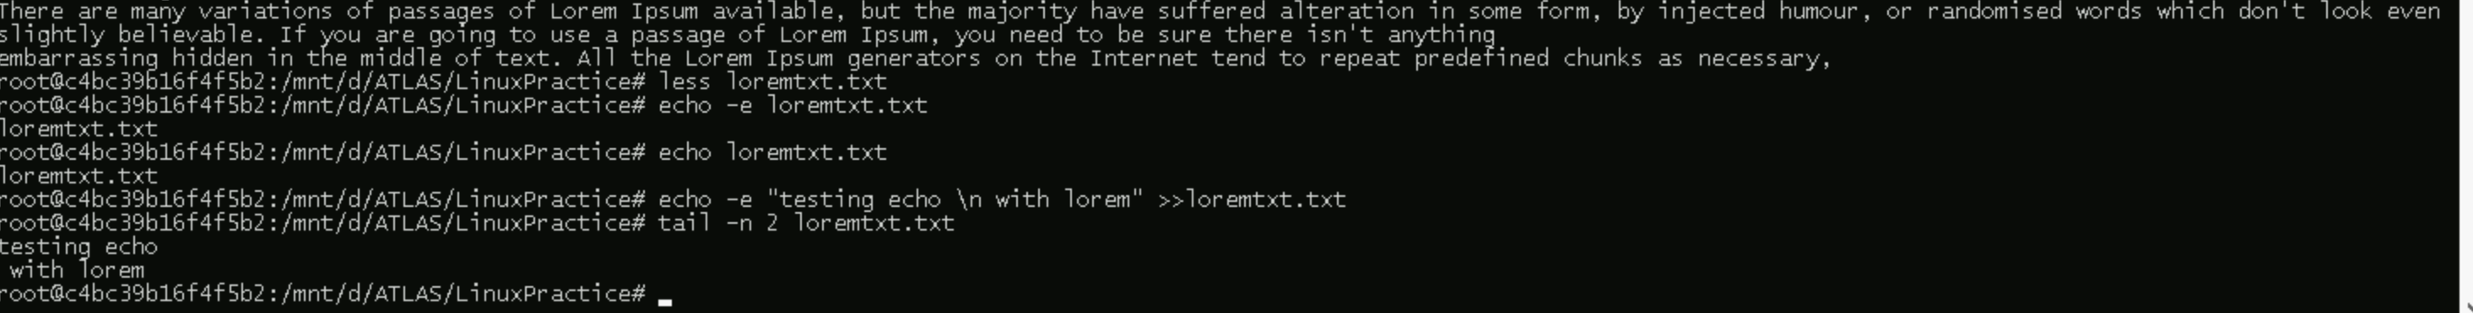

Task 17 – ls and ls with -l

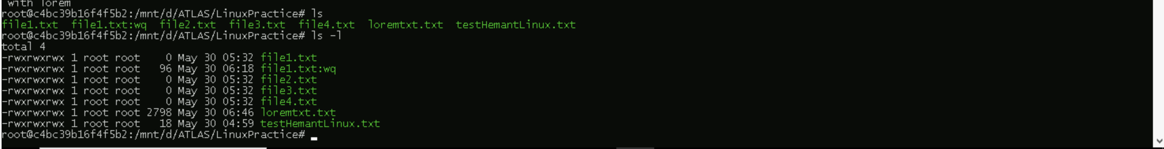

Task 18

1. TOUCH - Primary Purpose: Create empty files or update timestamps
2. CAT - Display, combine, and create files with content
3. Echo - Print text or variables to output

Task 19

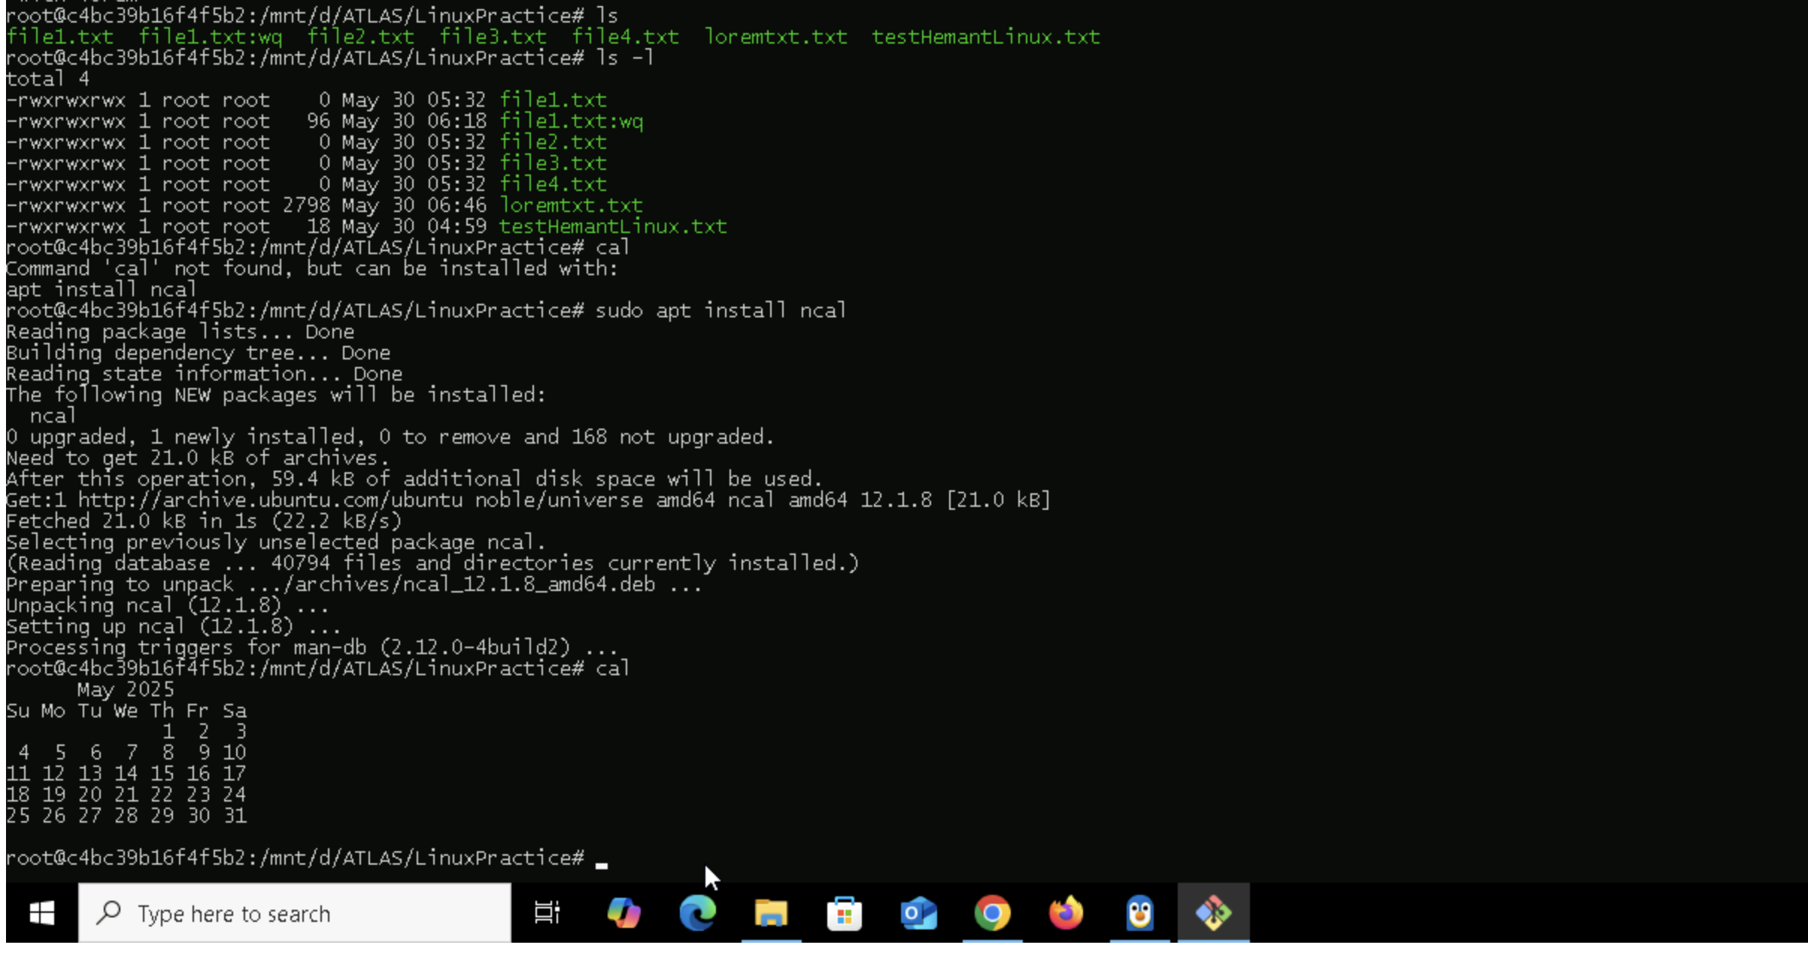

Task 20

Cd ..

Task 21

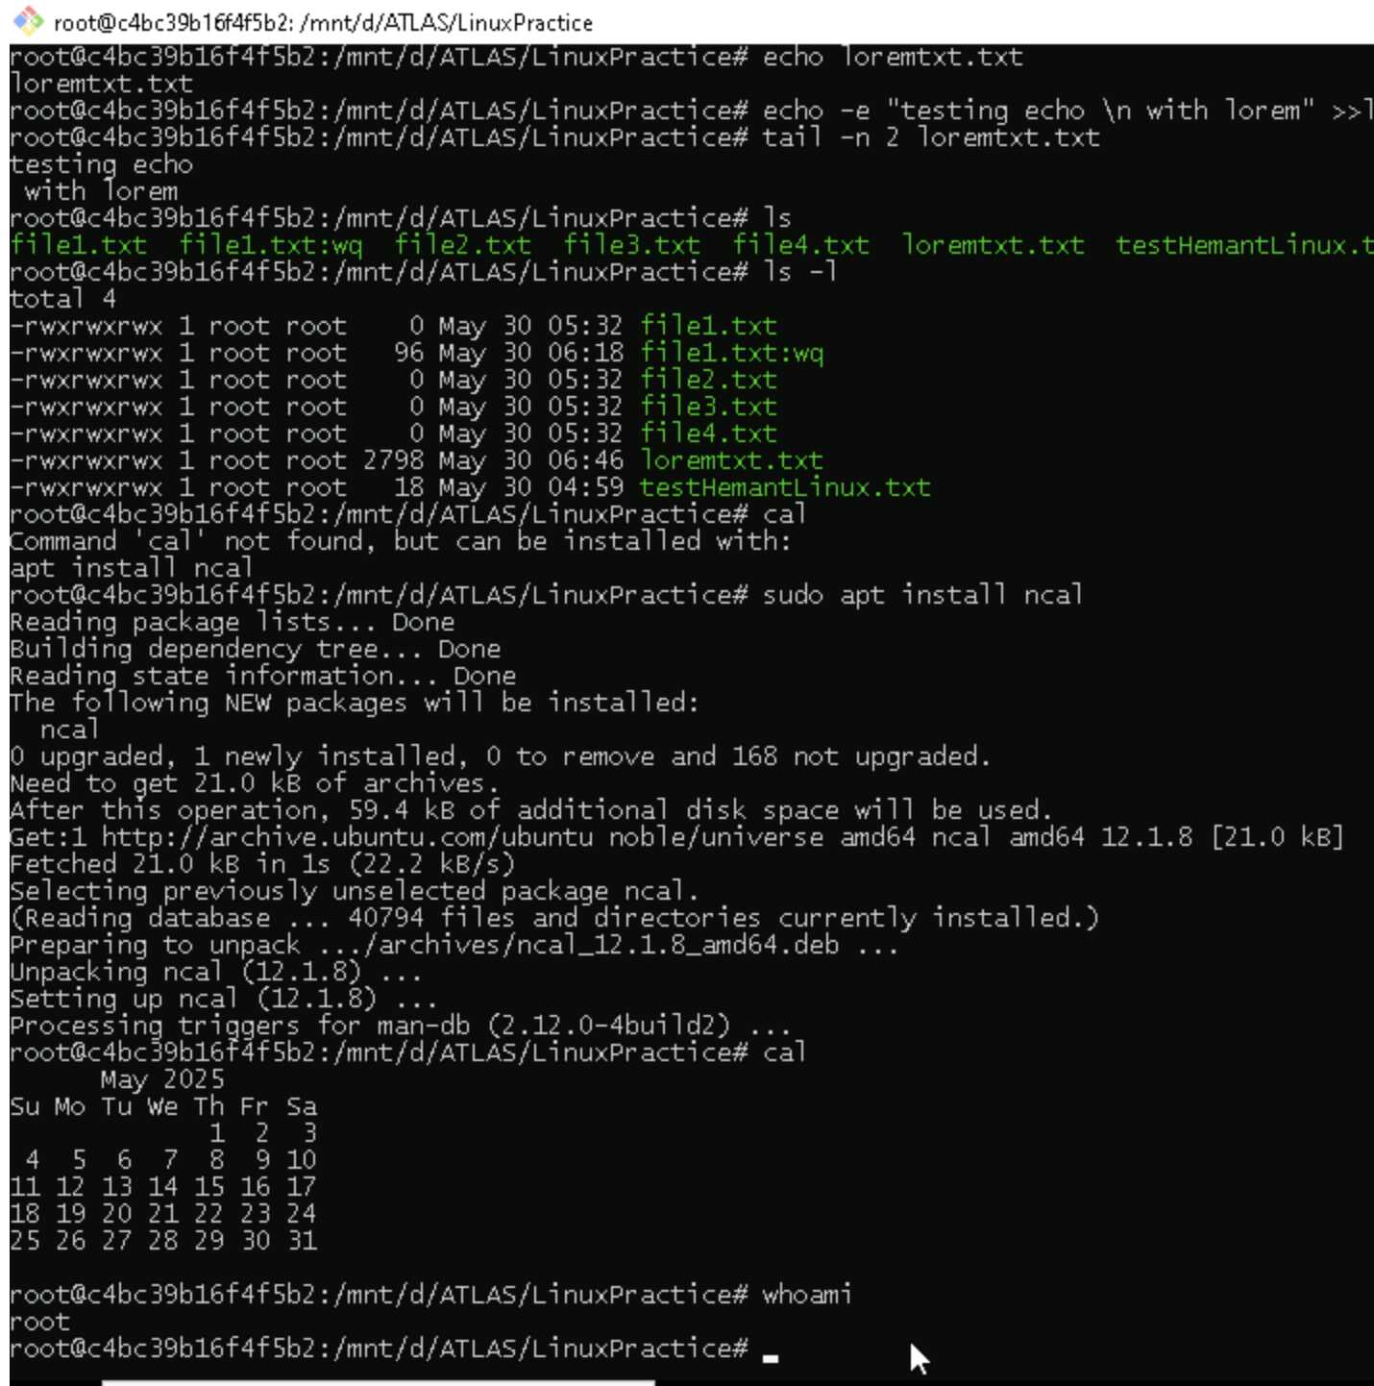

Task 22

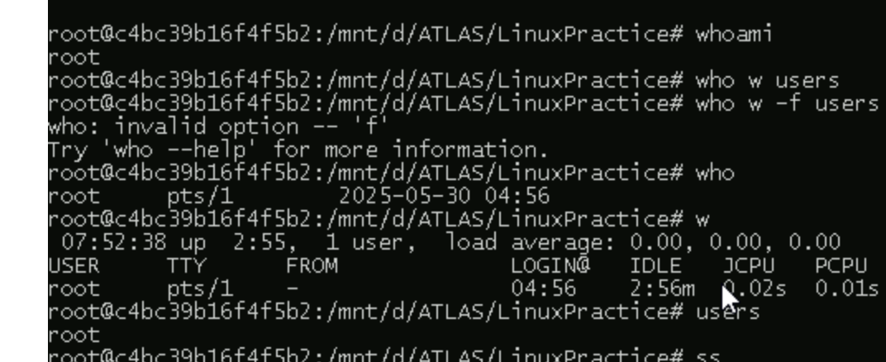

Task 23

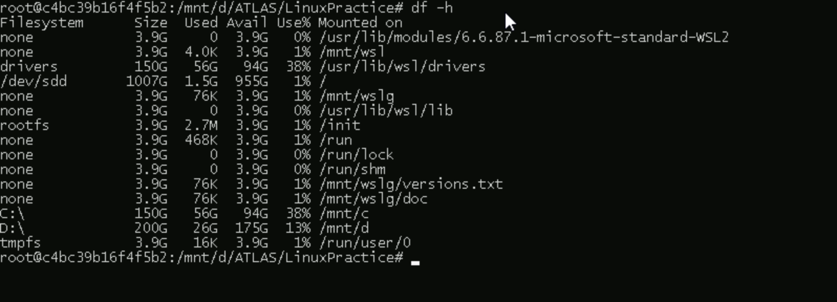

Task 25-26

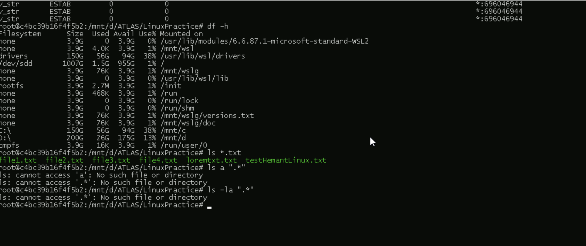

Task 26



Task 27

. stand for current directory and .. for parent directory

Task 28

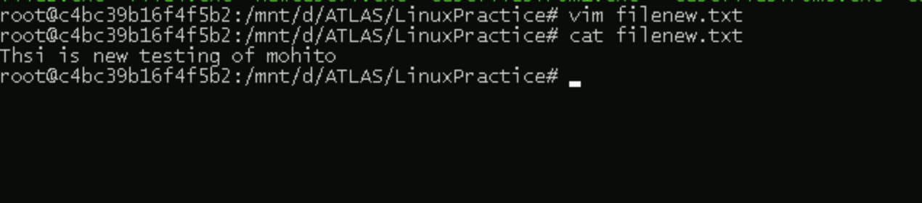

Task 29

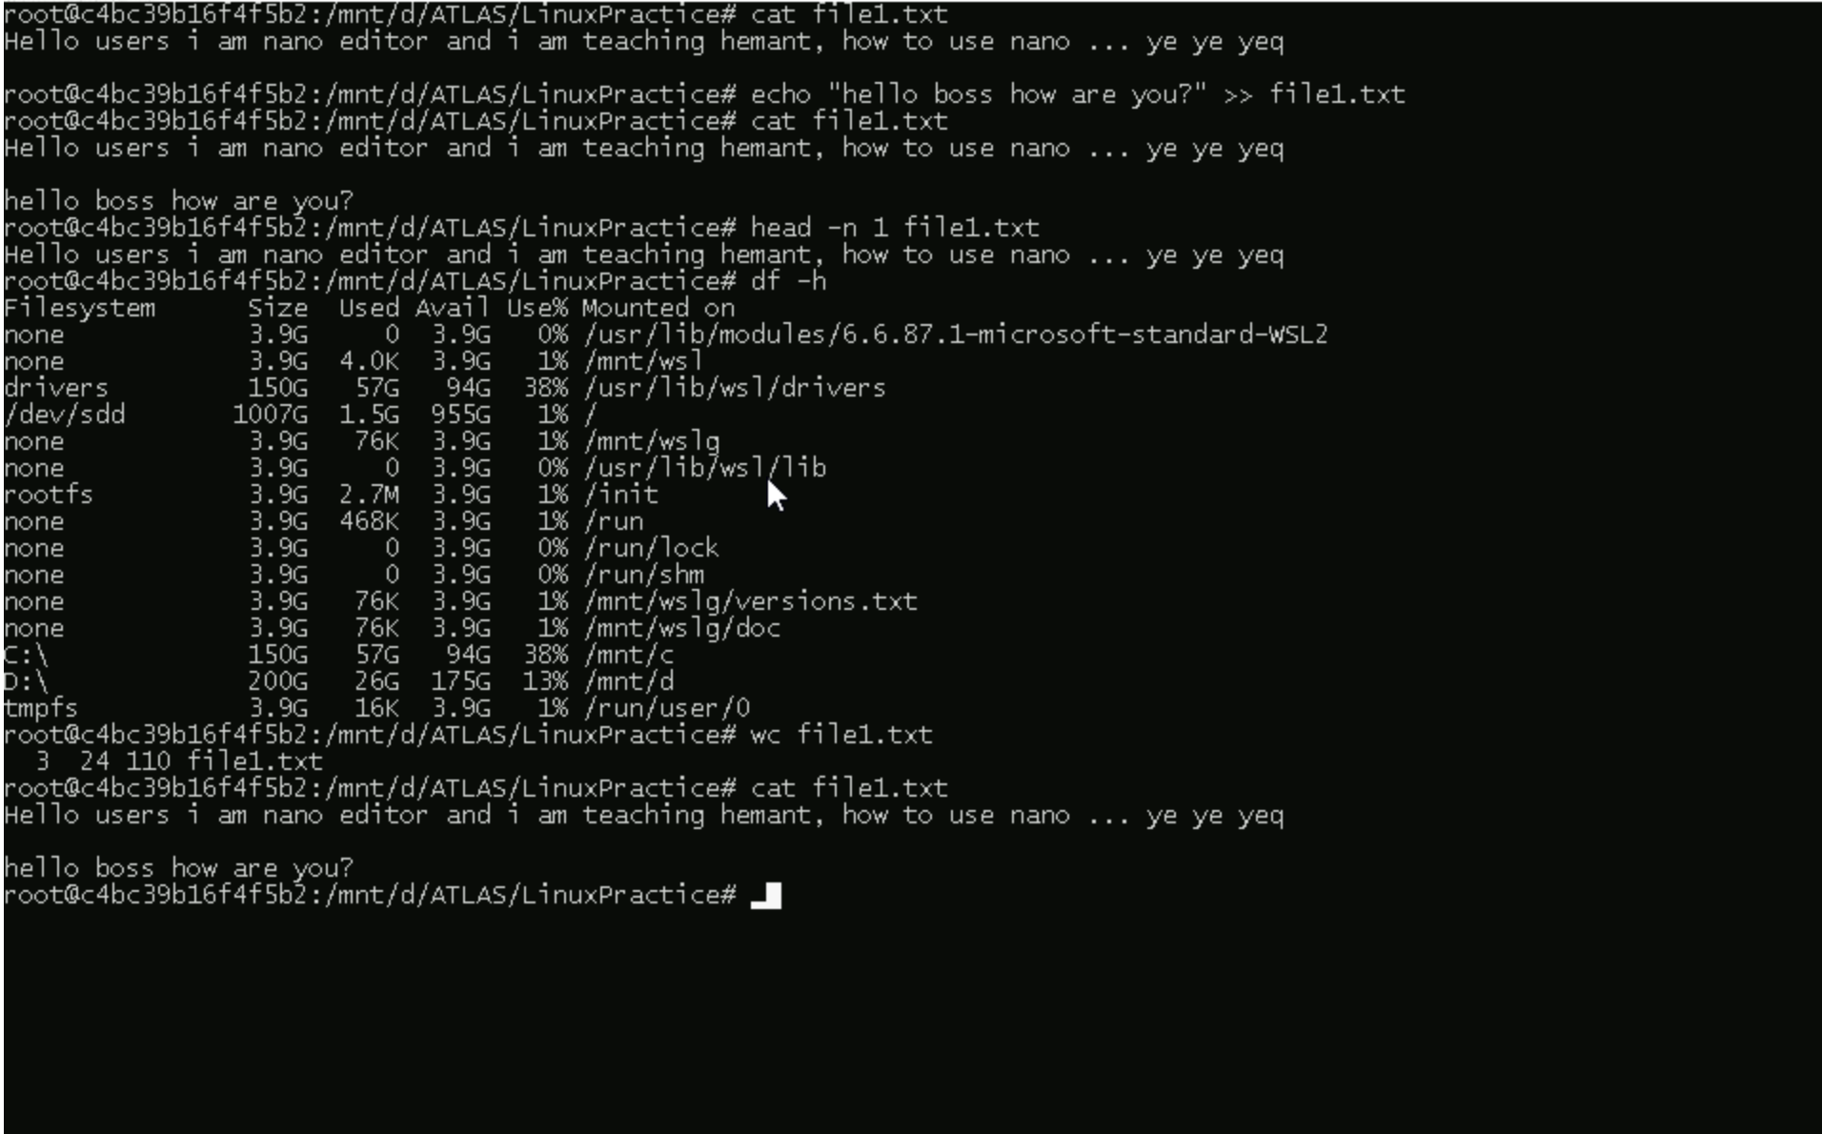

Task 30

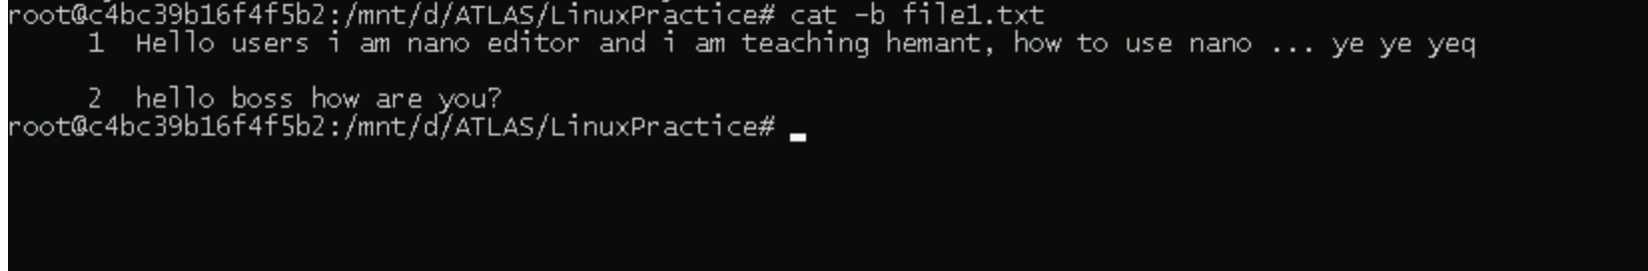

Task 31-32

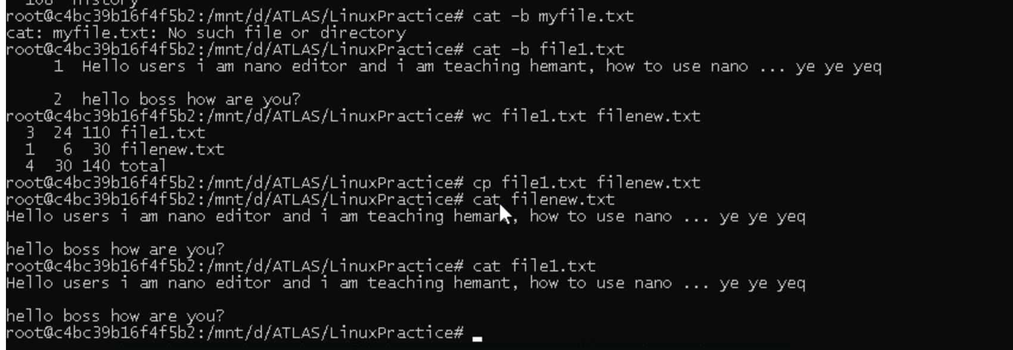

Task 33-34



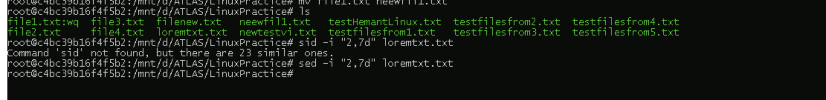

Task 35



Task 36-38

